

PROTOTYPICAL

CSEI

SET UP

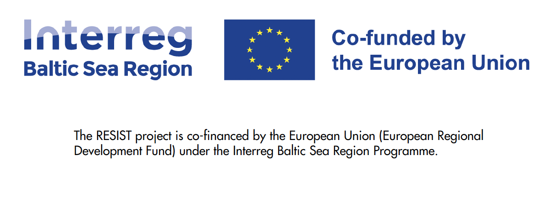
This concept paper is prepared as part of the project Regional Ecosystems for Social Innovation and Social Transformation (RESIST) project
Disclaimer: The European Commission support to produce this publication does not constitute endorsement of the contents which reflects the views only of the authors, and the Commission cannot be held responsible for any use which may be made of the information contained therein.

Table of Contents

The RESIST project 2
Introduction 3
1. The Core of a CSEI 6
The Core Activities of a CSEI 6
2. The Process: How to access the establishment of a CSEI 8
1) Describe: analyse the preconditions of a CSEI (baseline and starting point) 8
2) Define: success factors and vision (shared target picture) 9
3) Decide: focus areas (priorities for reaching success) 10
4) Define: one goal per focus area (clear targets) 11
5) Draft: steps and measures (implementation plan per goal) 11
Using the same steps for evaluation (not just creation) 12
3. Dimensions of the CSEI model 12
I. Membership model 12
II. Cross sectoral composition 13
III. Operational model 15
IV. Coordinating body 16
V. Financial model 17
VI. Portfolio of services 18
VII. Viable purpose 19
VIII. Collaboration among stakeholders 21
4. Examples of existing CSEI clusters 22
I. National Audit Union of Social Cooperatives (Poland) 23
Cluster story 23
II. Hamburg Alliance for Social Entrepreneurship (Germany) 24
Cluster story 25
5. Key Learnings from Practice 26

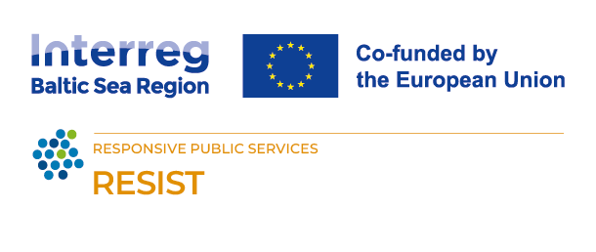
The RESIST project
This concept paper on a prototypical CSEI setup was funded by European Commission’s Interreg Baltic Sea Region Programme.
In the project RESIST (Regional Ecosystems for Social Innovation and Social Transformation), regional authorities, business support organisations and sectoral agencies develop a model of how to open up existing regional innovation ecosystems for social innovators and social entrepreneurs tackling societal and environmental challenges.
Social innovators and social entrepreneurs can play an important role in finding creative and unconventional solutions to current transformative challenges such as migration, the transition to a carbon neutral society, or digitisation. But to turn good ideas into practice they need help – in terms of qualification, funding and access to markets and cooperation partners. Regional public authorities, business support organisations and sectoral agencies in the Baltic Sea Region are already very effectively providing such support to mainstream innovators and entrepreneurs, but they have yet to realise the benefits of adapting their offers to the needs of social enterprises. The RESIST project supports these institutions in creating better and more supportive regional ecosystems for social innovation (SI) and social entrepreneurship (SE) and in making existing innovation support more accessible for social entrepreneurs. The project partners explore the concept of “clusters of social and ecological innovation” (CSEI) as a model for fostering cross-sectoral collaboration, and they develop and test a programme to improve the capacity of innovation support actors to foster social innovation. In the long run, the objective is to raise the number of CSEIs in the BSR and to facilitate cooperation between them. Throughout the process, the involved regions will also collect ideas and recommendations for improving the integration of social innovation in their regional innovation strategies.

Introduction
The purpose of this concept paper is to describe the prototypical setup of a Cluster of social and ecological innovation (CSEI) and facilitate the establishment or evaluation of a regionally adapted CSEI.
In the first part, it explains the CSEI concept, presents the “core” as the foundation of any CSEI to be and depicts the steps to create an action plan for the establishment of a CSEI on a regional level. Hence, the process is not only applicable for developing a CSEI design from scratch but also for the evaluation of an already existing CSEI or any network that presumably could be classified as a cluster of this kind.
The second part presents the eight dimensions that can be used to describe any CSEI. That includes specifying membership and financing models, types of coordinating bodies or cluster organisations, and assessing how suitable they are for different regional and socio-economic contexts and strategic objectives. Furthermore, the paper will also present suggestions for designing other operational aspects of a functioning ecosystem, such as services provided by the cluster, physical spaces or (digital) knowledge management & transfer, networking and matchmaking mechanisms between various organisations involved in (social) innovation generation, funding, education, marketing and awareness raising.
After this rather abstract specifications and recommendations, the guide concludes with observations from practice which are considered to be comprehensive and useful regardless of context and specific preconditions.
The guide is aimed at everyone who helps shape, support, or implement a CSEI cluster in a region – especially cluster coordinators or backbone teams, public-sector partners working on regional innovation and social policy, ecosystem intermediaries (hubs, incubators, networks), social innovation and social entrepreneurship actors, funders, and key partners from research, business, and civil society who contribute resources, legitimacy, or routes to implementation.
If you are interested in starting a CSEI in your region or you know of a cluster-like organisation or network in your region which tackles Social and Ecological Innovation, this guide is for you!

CSEI concept
Social economy clusters or Cluster of social and ecological innovation (CSEI) are “Groups of social economy enterprises and other related supporting and economic actors that cooperate in a particular location to increase their joint social and ecologic impact by enhancing their cooperation, pooling resources and innovation capacity” (European Cluster Collaboration Platform).
CSEI represents an innovative model of collaboration that benefits various groups of stakeholders for instance: public administration, social entrepreneurs and academic institutions. Below, we outline how each of these groups can benefit from participating in CSEI.

Public Administration
Local and regional development: Collaboration with CSEI enables local authorities and decision-makers to support sustainable social and ecological development. These initiatives focus on addressing local issues through social innovations, contributing to the improvement of residents' quality of life.
Increased efficiency of public actions: Participation in clusters allows for more efficient use of public resources through collaboration with the private and social sectors. Clusters act as platforms for exchanging knowledge and resources, accelerating the implementation of local development strategies.
Securing funding: CSEI clusters can assist in obtaining funds from various sources, including EU programs, supporting the long-term financial stability of local projects. Public support for clusters also increases the chances of securing external funding.

Social Entrepreneurs
Support and development: Clusters offer social entrepreneurs access to a wide range of services, including business incubation, microfinance options, networking opportunities, and market development support. This enables social entrepreneurs to scale their operations and increase their social impact.
Collaboration and innovation: CSEI promote collaboration between different sectors, fostering innovation and the creation of new solutions for social and ecological challenges. Social entrepreneurs can benefit from the knowledge and resources of academic, public, and private partners, enhancing their competitiveness and ability to innovate.
Community building: Participation in clusters supports the building of strong local communities by engaging various stakeholders. Social entrepreneurs can establish valuable relationships that help achieve common goals and strengthen social solidarity.

Academic Institutions
Research opportunities: Universities participating in CSEI gain access to unique research opportunities arising from close collaboration with the social and public sectors. This enables the conduct of practical research with direct applications and impact on the local community.
Knowledge transfer: Clusters create platforms for knowledge transfer between universities and other sectors, promoting the practical application of academic theories. Collaboration with social entrepreneurs and public institutions provides students and researchers with valuable experiences.
Community engagement: Participation in CSEI increases universities' involvement in local social and ecological initiatives. Universities can play a leading role in promoting sustainable development and social innovations, positively impacting their image and reputation.

General success factors on clusters

- Idea: In order to develop, the cluster must have a viable idea towards which the business can be oriented.
- Activities: There must be activities that create benefit and value from being part of the cluster.
- Organization: There is an organization that coordinates and develops the cluster’s activities and manages relationships necessary for its growth and development.
- Driving forces and commitment: There is a passionate and committed member(s) who constitute the force of activity and change in the cluster. The cluster needs a champion(s)!
- Critical mass: A cluster consists of a group of members and among these there should be both critical mass in number and a diversity for the cluster to function effectively.

A cluster organization like a company has:
- a development course that includes a process from start to an established organization where success in development is dependent on a clear idea that satisfies a need, individuals' driving forces and commitment and an anchoring in stakeholders.
- a task to satisfy a target group and within the framework of this develop an ability to both attract and manage resources.
(Magnus Klofsten, researcher at Linköping University)

A spider diagram model of the CSEI concept
For modeling the CSEI concept, a spider diagram was chosen. For the eight different dimensions (membership model, cross-sectoral composition, “ownership” and operational model, coordinating body, financial mode, portfolio of services/activities, viable purpose/idea, collaboration among stakeholders), a region can review the current situation of each of the dimensions, ranking each from low/small/weak up to large/strong/high to visualize, which parts of the CSEI need more development.
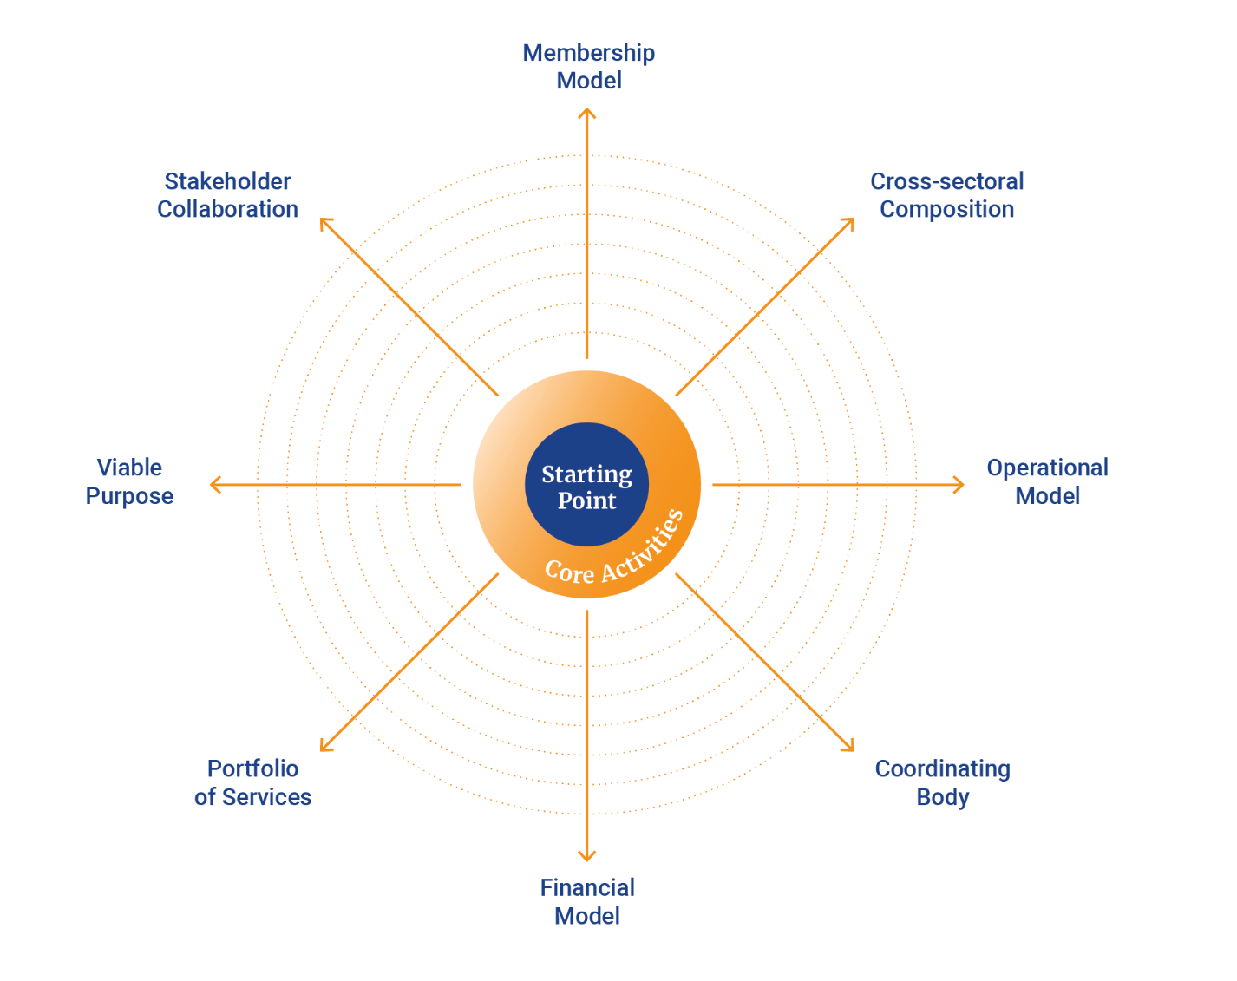

The Core Activities of a CSEI

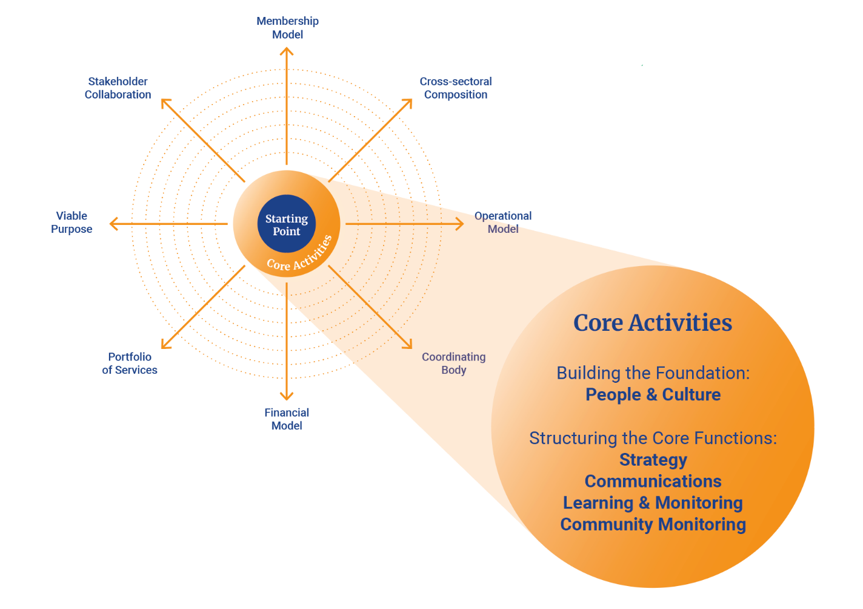
Establishing the Core Activities of an CSEI
The creation of an CSEI begins with developing a stable core that can coordinate both internal and external interactions with the wider ecosystem of structures and actors. A fundamental early step is defining the governance model: determining who is committed to the collaboration, how accountability will be practiced, and which decision‑making structures are necessary. It is equally important to clarify the financial framework—whether funding is available for core activities and how that funding should be allocated to ensure it is used effectively by the actors involved.

Building the Foundation: People and Culture
Once the governance and infrastructure of the cluster are in place, attention turns to the core functions that will nurture and sustain the ecosystem. A key element of this work is understanding the people and skills required. This includes identifying which competencies are essential for developing the overarching vision and specifying who needs to be connected to drive the initiative forward.
Because the cluster will involve a diverse array of organizations and individuals, establishing a shared culture early in the process is crucial. Setting clear principles, guidelines, and expectations for collaboration reduces uncertainty, aligns intentions, and creates a more coherent basis for collective action. Such cultural groundwork helps to minimise friction and ensures that participants understand how to work effectively within the ecosystem.

Structuring the Core Functions
To ensure clarity and reduce overlapping responsibilities, the work of the core can be organized into four primary functions. These functions make it easier to navigate complexity and to ensure that the ecosystem receives support in all the areas necessary for long‑term sustainability.

Strategy
The strategic function is essential because the cluster will interact with a wide spectrum of actors—ranging from grassroots initiatives to potential international partners. To manage this diversity, the core should include individuals with strong strategic capabilities and the experience needed to work across different systems. Their role is to provide direction, anticipate challenges, and guide the cluster through a constantly evolving landscape.

Communications
Communication is a decisive success factor in ecosystem‑oriented work. The core must be able to facilitate internal dialogue across the network while also building understanding among external stakeholders. This involves translating complex processes of co‑creation and collaboration into messaging that is accessible, clear, and supportive of the cluster’s goals. Without strong communication, misunderstandings grow, collaboration weakens, and progress becomes difficult to maintain.

Learning and Monitoring
As clusters are still a relatively new form of organizational arrangement, the knowledge and skills needed for co‑creation and ecosystem collaboration may be limited among participants. For this reason, a strong emphasis on learning and monitoring is vital. This function focuses on building collaborative capacity, capturing insights, tracking progress, and documenting results and success stories. These results help members justify their involvement to their respective stakeholders—whether owners, funders, customers, members, or taxpayers—and strengthen the legitimacy of the cluster’s continued development.

Community Management
Because an CSEI consists of many actors working together as an interconnected ecosystem, community management becomes a central component of the core work. This function requires individuals who are skilled at relationship building, coordination, process and project management, and event design. Their task is to maintain the social fabric of the ecosystem, support meaningful interactions, and ensure that activities unfold smoothly and thoughtfully. Effective community management keeps the ecosystem vibrant, connected, and capable of evolving over time.

HEADING!!!!!
Next step, when forming the core, is to do a proper analysis of the ecosystem and its potential stakeholders. You want to know what kind of activities the ecosystem contains and what potential benefits they could have by being connected to a structure as a CSEI. What kind of value the stakeholders produce and the level of connections they have to each other. To be able to be a functional supporting structure, it’s good to have a clear picture of the rules and regulations in your context regarding the purpose of the CSEI as well as knowing what policies support your cause on the regional and national level. As a support structure, you should collect knowledge about the potential funding landscape for your stakeholders, as well as possible funding streams for the structure itself. This will increase your relevance for potential members and contribute to a sustainable future for the cluster. As the cluster is supposed to be highly in tuned with the context, which it intends to serve, initially there is much to gain in mapping out cultural and social assets. Questions to ask yourself could be, who is it that has a high level of influence and how are you in touch with the local culture of creating this kind of initiative?

2. The Process: How to access the establishment of a CSEI

How to create or evaluate a CSEI using the 5-step process
This process works both as...
...a creation method (building a CSEI cluster from scratch based on the previously described core and existing resources) and as
...an evaluation method (checking maturity, gaps, and next development priorities).
The logic is simple: start with the status quo, define a shared picture of success, prioritize what is most essential or obvious, translate priorities into measurable goals, and then design an action plan that is concrete enough to implement.
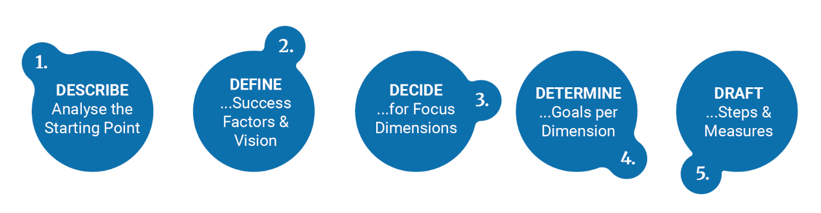

1. DESCRIBE: Analyse the Starting Point of your CSEI (baseline and preconditions)
Begin with a structured inventory of the status quo, thus the CSEI foundation in your region. The goal is not to judge quality yet, but to establish a common understanding of the starting point: what resources, capabilities, and conditions are already present – internally and externally.
Internal resources to analyse
- People & skills: Which expertise and capacity do we have at hand?
- Financial base: Is the financing for the initiative as secured or which financial resources or funding streams can we utilize?
- Established governance practices: Do we have already established decision-making routines, accountability, roles and coordination mechanisms?
- Organisational culture: On which cultural basement do we build the CSEI? Think about terms like trust, collaboration norms, openness to learning, conflict handling, experimentation.
- Infrastructure: Which physical spaces, digital tools, data access and administrative capacity can you rely on?
External resources to collect
- Ecosystem activities: Which relevant existing initiatives, collaborations, events, projects, networks or intermediaries are already established in your region?
- Market connections: Are you aware of any potential partnerships with companies, procurement opportunities, or signs of demand from the market?
- Policy & regulation: Which enabling or limiting frameworks, public priorities, compliance constraints or potential incentives should be taken into account?
- Funding landscape: Do you have access to any relevant funders, public programmes, philanthropic sources or investment actors and knowledge of specific eligibility criteria?
- Stakeholder networks: Who are the key actors across sectors and connectors to consider? Are there any power dynamics or trust relationships that you need to take into account?
- Cultural & social assets: What are the outlines of your region’s local identity, social capital, community engagement, civic participation, legitimacy.
- Stakeholder networks: Who are the key actors across sectors and connectors to consider? Are there any power dynamics or trust relationships that you need to take into account?
Output of Step 1
A clear baseline that can be used for evaluation: “This is what we currently have and what we can build on.”
Your status quo analysis can be captured as a short profile, a resource map, and/or an initial rating per spider-diagram dimension.

2. DEFINE: Success Factors & Vision (shared target picture)
Next, articulate what the CSEI should ideally become in your region. This step creates alignment: without a shared vision, later decisions tend to be scattered or driven by the loudest stakeholders.
Key questions to guide the vision:
- What is the purpose of the CSEI cluster here, hence, what problem(s) does it help solve?
- What would “high performance” look like in practice (not just in slogans)?
- How would people in the region experience the CSEI: as a platform, a network, a support structure, a service?
- What are the non-negotiable success factors (e.g., legitimacy, governance quality, financial resilience, inclusion)?
You can either define an overall meta-vision or use the spider diagram dimensions (“spider legs”) to make the vision mtangible. For each area, describe what “good” looks like in your context. This provides a common language and avoids abstract visions that are hard to operationalize.
Output of Step 2
A concise vision statement in a few sentences plus success factors, optionally translated into an “ideal spider profile” that describes the desired maturity level across dimensions.

3. DECIDE: Focus Dimensions (priorities for reaching success)
With status quo (Step 1) and vision (Step 2) on the table, identify the gap: what is missing or underdeveloped and what is most critical to address first. This is where you make trade-offs deliberately. Since resources are limited, the aim is to avoid trying to improve everything at once.
How to select focus areas well:
- Compare baseline vs. vision across the spider legs: where are the largest gaps?
- Look for bottlenecks: areas that block progress everywhere else (often governance, funding, coordination capacity).
- Look for leverage points: areas where improvement will unlock multiple outcomes (e.g., a strong stakeholder network might accelerate funding access and pilot partnerships).
- Consider feasibility: what can realistically be improved within your time horizon and resource constraints?
Define a timeframe and choose approximately three focus dimensions to prioritize initially. This keeps attention and energy concentrated and makes progress visible.
Optional: If it helps you with your decision-making and prioritization, you can already set a time frame for a second phase in which you will address the dimensions with the second priority level.
Output of Step 3
A short list of priority focus dimensions or a corresponding indication in the diagram, including a brief rationale for why these were chosen now.

4) Define: one goal per focus dimension (clear targets)
For each focus area, define one goal that translates your vision into a measurable target. This is the bridge between strategy and action: it turns “we want a strong ecosystem” into “we will achieve X by Y.”
Use SMART goals:
- Specific: clear about what will exist or change.
- Measurable: includes indicators or evidence.
- Achievable: realistic given capacity.
- Relevant: linked to the vision/success factors.
- Time-bound: includes a timeline.
Good goals often include both:
- an outcome component (what improves in the ecosystem), and
- a capacity component (what the CSEI can reliably do).
Output of Step 4
Three goals (one per focus dimension), each written as a SMART statement with simple indicators.

5) Draft: steps and measures (implementation plan per goal)
Finally, design the action plan: what concrete steps will move each focus area from status quo toward the goal?
This is where you make the plan operational:
- Identify measures (activities, interventions, structures, pilots, partnerships).
- Define owners (who is responsible) and contributors.
- Define milestones (what progress looks like at 30/60/90 days or quarterly).
- Clarify resources needed (time, funding, tools, political support, expertise).
- Include a simple monitoring routine (how you’ll track progress and adjust).
To keep it implementable, formulate steps at a practical level (not just “build capacity,” but “run 3 partner roundtables,” “set up governance charter,” “pilot 2 use cases,” “create funding pipeline,” etc.).
Output of Step 5
A lightweight roadmap per focus area: measures, owners, milestones, and tracking approach.

Using the same steps for evaluation (not just creation)
If you’re evaluating an existing CSEI, the steps remain the same, but the intent shifts depending on whether there are already defined priorities, goals and measure or whether you want to use the five steps to enter a new phase of development for the cluster:
- Step 1 becomes a maturity snapshot (strengths, gaps, constraints).
- Step 2 tests whether there is a shared and current vision (or whether stakeholders have drifted).
- Step 3 either...
... surfaces whether priorities are well-chosen (or too broad / not aligned with bottlenecks), or...
...defines the priorities for the cluster’s upcoming development phase.
- Step 4 either...
...checks whether goals are measurable and meaningful (or vague / untrackable), or...
...sets new goals.
- Step 5 either...
...reviews whether measures are concrete, resourced, and owned (or “nice ideas” without delivery structures), or...
...outlines measures to reach the goals.

3. Dimensions of the CSEI model
In the following chapters, the eight dimensions of the CSEI model (the spider diagram) are explained. After a paragraph on what the RESIST team means by the respective dimensions, examples are following and giving an insight into practice. Each chapter is closed by recommendations for the target group on what to think about this dimension when put into practice.

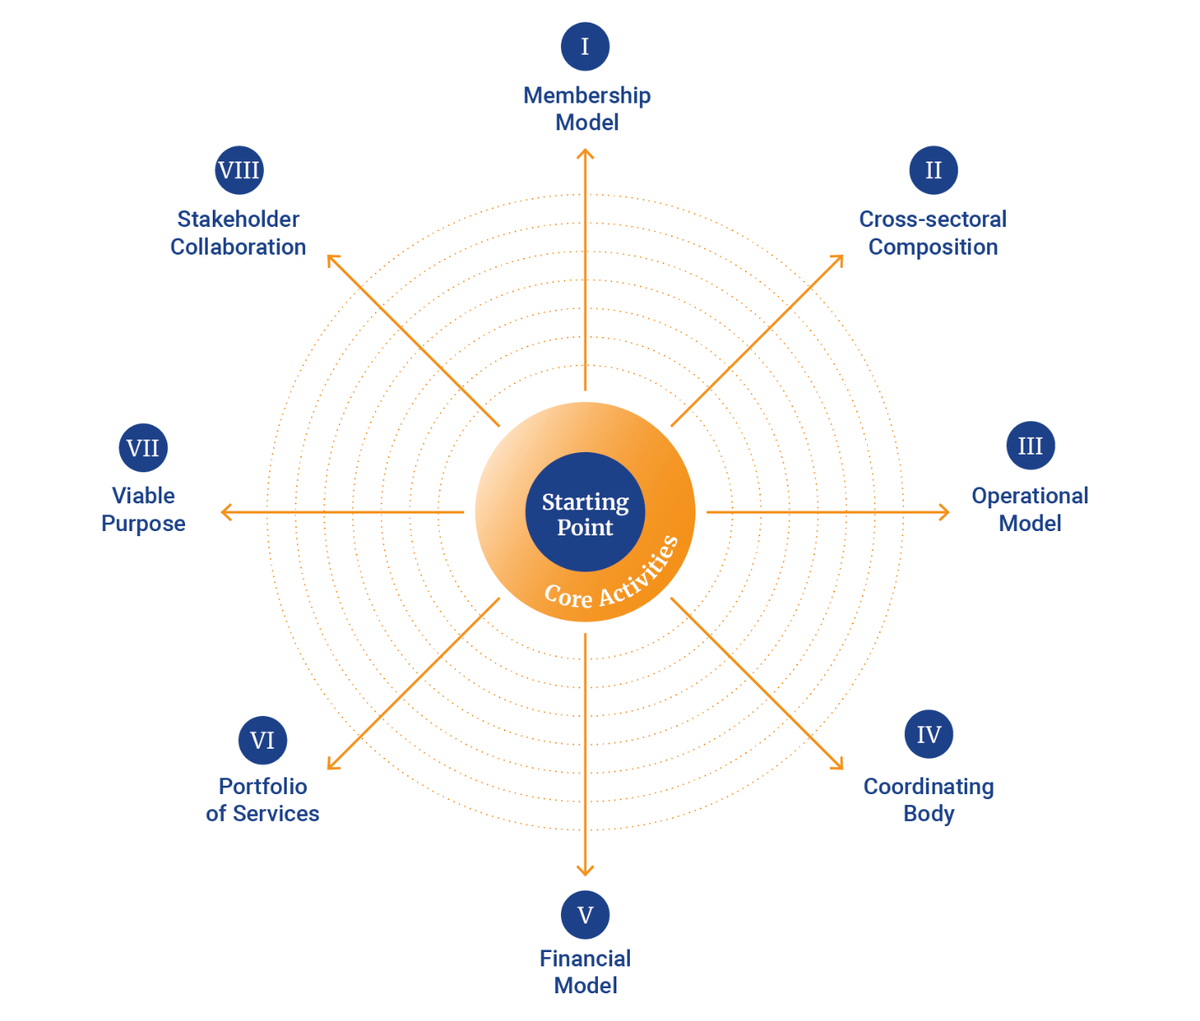

I. Membership model
Identifying the relevant actors within a social- and ecological cluster is crucial when the objective is to consolidate efforts towards shared goals. Membership plays a pivotal role in fostering predictability among these actors, thereby facilitating effective collaboration and coordination.
Organizing membership in a cluster requires a thoughtful approach that considers the unique needs and capabilities of its actors, while also ensuring financial sustainability and alignment with the cluster’s overarching goals. This balance is key to the successful operation and impact of a social- and ecological cluster.

Different examples of membership models
Inspired by the Expert Group on Social Economy and Social Enterprises (GECES), membership in a cluster can be categorised into three fundamental types:
- Closed and Formalised Membership: This type is clear-cut, typically involving regular membership fees.
- Open Membership: This category includes various forms of membership. Some do not require regular payments, offering open membership. A variant of this type is based on cooperative traditions where members are also owners via shared stakes, as seen in Berziklatu and Modragon. An interesting example is Teple Misto (UA), where access to the cluster site is facilitated through a crowdfunding system.
- Informal Membership: This type does not involve recurring payments. Membership is determined based on delegation. Examples include The Partnership for Social Innovation in Örebro County (SE), Impact City The Hague (NL), and Grappe Construction Bruxelles (BE). These Clustered Social Economy and Innovation Initiatives (CSEI) tend to have strong ties with public authorities or a policy strategy.
It's important to note that members do not necessarily have to be “social economy” actors. However, they should align with similar local societal or ecological missions. There is also the category of associated membership, where members are loosely connected participants in the cluster.
What to think about?
- Membership criteria: Define clear criteria for membership and ensure that members share the cluster's vision and commitment to social and ecological innovation. Decide if membership is open to individuals, organizations, or both.
- Active participation: Participation is key to ensure energy, vitality, and progress in a cluster, active participation in meetings and events.
- Expectations of Members: Clarify what is expected of members such as: contribute to the clusters development, adherence to the cluster’s values and guidelines.
- Inclusion and diversity: Ensure membership is accessible to a broad and inclusive group of people, avoid structures that might exclude less resourceful actors.
- Digital and physical meeting spaces: Provide both digital and physical platforms for member interaction, build a digital infrastructure to enable remote collaboration, choose and design your physical space(s) so everyone feels welcome and included

II. Cross-sectoral composition
A cross-sectoral composition refers to the diverse backgrounds of the initiators and owners of the cluster’s organization. We have chosen to define four sectors from which these individuals and entities originate:
- Public sector: Government agencies, public institutions, and municipal bodies.
- Private sector: Corporations, small and medium enterprises (SMEs), and private investors.
- Social economy and civil society: Social enterprises, non-governmental organizations (NGOs), community groups, and non-profits.
- Academic and research institutions: Universities, research centers, and think tanks.
We believe that a broad cross-sector collaboration favours the development of social and ecological innovation, and therefore wants to show, and encourage, different types of cross-sector collaboration.
As we can see in the previous report from GECES (The expert group on social economy and social enterprises in EU) most part of the already existing clusters in EU consists of clusters with mainly social economy actors and hybrid clusters with social economy and SMEs.
Their report state that the fact that a cluster is based in collectivism and involves cooperation among the different organisations that integrate it, this may explain that at its birth, and in the majority of the cases, there is already a collective structure.
Different examples of cross sectoral composition
- Actors in the cluster mainly come from the social economy sector (one sector)
- Actors in the cluster mainly come from public and social economy organizations (two sectors)
- Actors in the cluster mainly come from private and social economy organizations (two sectors)
- Actors in the cluster mainly come from the social economy, public and academic sector (three sectors)
- Actors in the cluster mainly come from the social economy, private and public sector (three sectors)
- Other types of cross sectoral compositions
What to think about?
Involving the local municipality or authority in the cluster approach is highly desirable. Especially since you, together with the municipality, you then can adapt the cluster purpose to the local context and existing strategies. It also ensures greater relevance among politicians and decision-makers and opens up opportunities for public financial support.
According to the GECES report on Clusters of Social and Ecological Innovation (CSEI), almost all clusters embody the multiple partnership approach, integrating at least two to three types of actors in their composition. These clusters are typically cross-sectoral in terms of sector of activity (NACE), indicating that their drivers often extend beyond merely enhancing local sectoral competitiveness. Instead, they are motivated by broader social and environmental objectives.
The vast majority of these clusters operate within specific political or administrative jurisdictions, emphasizing the importance of proximity. This geographical confinement ensures that activities are tailored to the local context and needs, fostering stronger community ties and more effective interventions.

III. Operational model
An operational model in the context of clusters of social and ecological innovation refers to the structure and methods by which these clusters operate to achieve their goals. This includes aspects such as leadership, governance, and the distribution of responsibilities and ownership.
Clusters can be led by public entities, private companies, academia, NGO’s or a combination of sectors. Public leadership often involves local or regional governments, while private leadership might include social enterprises, non-profits, and private sector companies. In many successful clusters, there is a blend of both, leveraging public resources and private sector innovation.
Governance: Process of decision-finding and making in a democratic and participative logic Governance within these clusters is characterized by democratic and participative decision-making processes. This includes inclusive governance where interventions are managed collectively by entities representing different sectors. Such a setup ensures anchored and more effective decisions, promoting a harmonious social environment and sociocracy (inclusive and participative decision-making).
Different examples of operational models
Examples of operational models in clusters of social and ecological innovation include:
  - Public Clusters: These aim to create societal wealth and jobs through reinforced networking of social economy organizations present in a specific area. They often have a formal structure and are supported by public policies and funding.
  - Entrepreneurial Clusters: These are similar to traditional industrial clusters but integrate social economy issues. They focus on increasing employability and integrating social innovation into their activities.
  - Social Clusters: These are formed by citizens to address local social needs, often in partnership with local authorities. Their primary goal is social innovation and community development.
What to think about?
Creating a successful operating model for a social and ecological cluster requires consideration of the purpose, members and local context of the cluster. Inclusivity and participation are fundamental, as an inclusive and participative governance structure ensures the rights and interests of all members, particularly the target groups, are respected.
Strong, positive, and democratic leadership is crucial for managing the cluster's complex dynamics effectively. Transparency and accountability in decision-making processes build trust and collaboration among members.
Clusters should aim for sustainable social impacts while maintaining flexibility to adapt to changing socio-economic conditions. This includes fostering innovative and culturally sensitive social intervention models.
Key components of a CSEI operational model include
Governance Structure: Clearly defined governance structures that outline the roles and responsibilities of different actors within the cluster, including leadership, management, and advisory roles. This ensures accountability and effective decision-making.
Stakeholder Engagement: Mechanisms for engaging and collaborating with a diverse range of stakeholders, including social enterprises, non-profit organizations, public authorities, private sector entities, and community groups. Effective stakeholder engagement fosters collaboration and resource sharing.
Decision-Making Processes: Transparent and inclusive decision-making processes that allow for the participation of all relevant stakeholders. This helps to ensure that the decisions made align with the collective goals and values of the cluster.
Resource Management: Efficient management of financial, human, and material resources to support the cluster's activities. This includes securing funding from various sources, managing budgets, and ensuring the sustainable use of resources.
Monitoring and Evaluation: Systems for monitoring and evaluating the performance and impact of the cluster's activities. This involves setting measurable goals, tracking progress, and making adjustments as needed to improve outcomes.
Communication and Coordination: Effective communication and coordination mechanisms to ensure that all stakeholders are informed and engaged. This includes regular meetings, updates, and the use of digital platforms for collaboration.

IV. Coordinating body
Group of people responsible for managing and guiding the cluster's activities and initiatives, including the portfolio of services. Can be a legally established cluster organisation with staff or an informally organized team, potentially relying on pro bono work.
This body is ensuring that the diverse stakeholders within the cluster work cohesively towards common goals. It involves organizing and harmonizing the efforts of various participants, including social enterprises, public authorities, educational institutions, and private sector entities.
A main task is to develop and oversee the implementation of strategic and operative plans that align with the cluster’s objectives, such as fostering social and ecological innovation.
Different examples of coordinating body
1. Hamburg Social Entrepreneurship Alliance (civic society entity): established as an association with office employing 5 FTE
2. Lithuanian Social Innovation Cluster (LSIC) (civic society entity)
3. “Our Agder” (public sector entity): The Agder County acts as secretariat and driving force of the regional cooperation structure
4. Samforma (civic society entity); the main task is to promote the social economy and the civil society sector in the north of Sweden
What to think about?
When establishing a coordinating body, the portfolio of services influences the team's required soft skills. A mutually signed constitution containing the CSEI’s mission might increase long-term commitment of the staff and/or board.
A legally established organization can enhance reliability and trust among stakeholders, providing a stable foundation for operations. However, establishing a new organization involves foundational costs, administrative efforts, and compliance with regulations, all of which must be budgeted for. Governance should reflect the cluster’s cross-sectoral nature, ensuring diverse representation in leadership.
Despite these challenges, legal autonomy allows the organization to independently apply for and manage projects, increasing its impact. Choosing the right legal form, potentially with non-profit status, is crucial for accessing diverse funding sources and ensuring sustainability. Ultimately, a well-structured CSEI can effectively deliver services, secure funding, and maintain credibility within the social innovation ecosystem.

V. Financial model
In the GECES report "Clusters of Social and Ecological Innovation in the European Union, Perspectives and Experiences," the concept of a financial model is critical to understanding how clusters can be sustained and scaled. You need resources to operate, coordinate and administrate the cluster organization. A financial model in this context refers to the strategies and mechanisms that clusters use to secure funding, manage financial resources, and ensure long-term sustainability.
Successful clusters often rely on a mix of funding sources, including public funding (e.g., grants from local, regional, or national governments), private investments, philanthropic contributions, and revenues generated from services or products offered by the cluster. This diversification helps mitigate the risk associated with dependence on a single funding stream.
Different examples of financial models
  - The members in the network pay a yearly fee which covers basic needs for the collaboration platform, that is run on a non-profit basis.
  - The cluster organization sell different services or arranges bigger conferences, meetings and events that generates an income to the coordinating body.
  - A public actor (municipality, region, state) provides funding to the coordination body. To be able to do that as a public actor it is helpful to have a supportive policy document in place.
  - The cluster organization, either alone or together with a public actor, seeks various forms of EU funds to address a specific societal challenge.
  - Establishing partnerships with other organizations, including government agencies, private sector companies and non-profits that open up new funding opportunities and shared resources.
A community crowdfunding model, e.g. Open Collective, which gives organizations, communities, projects a legal status to raise funding through subscription or one-time payment.
What to think about?
Clusters are encouraged to develop business models that include self-sustaining revenue streams. This could involve offering fee-based services and workshops or a membership model where members, for example, assist with resources based on how much they use a cluster's services. The goal is to reduce long-term dependency on external funding.
If the cluster will rely mostly on project financing, it is necessary to have a stable organization, a clear project strategy and sufficient liquid funds. A financial model solely reliant on project funding is particularly vulnerable due to the risk of having to shut down the services when the project ends, and that doesn’t create a continuity of competences, networks and partnerships which is so important when starting up a new cluster.
Therefore, it is highly desirable to anchor the ideas of a social and ecological cluster with a public financier. This anchoring provides a more secure financial foundation and reduces the risks associated with fluctuating project funding.

VI. Portfolio of services
A portfolio of services in the context of CSEIs refers to the diverse range of services provided by these clusters to support both their members and the communities they serve. The portfolio of services that the cluster chooses to offer its members, and the local community needs to be adapted to the local context and prevailing conditions.
The services to the community are designed to address economic, social, and environmental needs, thereby promoting sustainable development and social cohesion. The cluster also provides significant value to its members through a variety of means, which collectively enhance the individual and collective capabilities of the members.
Different examples of portfolios of services
Clusters of social and ecological innovation offer various services tailored to their specific goals and the needs of their members. Examples include:
- Economic Services: These services focus on economic development and job creation. They include business incubation, microfinance options, support for social enterprises, job creation initiatives, networking opportunities, and access to markets.
- Social Services: Clusters often provide services aimed at social inclusion and community development. These can include educational programs, health services, social integration initiatives, and support for vulnerable groups.
- Environmental Services: Services under this category are designed to promote sustainability and ecological balance. Examples include waste management, green space maintenance, renewable energy projects, and initiatives for circular economy practices.
- Technological Services: Many clusters offer technological support and innovation services, such as access to research and development facilities, technological training, and collaborative innovation projects.
- Networking opportunities: The cluster can facilitate connections among members, leading to collaborative projects, partnerships and joint ventures.
- Knowledge and expertise: The cluster can arrange training sessions, workshops, and seminars to enhance skills and knowledge in specific areas.
- Resources and support: The cluster can provide shared resources as co-working spaces, venues and assist with securing funding through grants, loans or EU-funded projects.
- Tailored business development: The cluster can provide personalized support for business planning, funding strategies, market analysis and customer contacts. Encouragement and support for adopting social and ecological friendly practices.
- Advocacy and influence: The cluster can mobilize stakeholders in policy-making processes, ensuring that the interest of the members is considered.
What to think about?
Target groups: When developing a portfolio of services, it is crucial to consider the target groups that will benefit from these services. This includes identifying the specific needs of various community members, such as entrepreneurs, vulnerable populations, and local businesses, and tailoring services to meet these needs effectively.
Integration with Local Ecosystem: Assess how the services fit within the local economic, social, and environmental ecosystem. This includes understanding the local context, identifying potential partners, and leveraging existing resources and infrastructures.
Regulatory and Policy Framework: Analyze the regulatory and policy environment to ensure compliance and to identify opportunities for support and collaboration with public authorities. This includes understanding local, regional, and national policies that can affect service delivery and cluster operations.
Sustainability and Impact Measurement: Implement mechanisms for measuring the impact of the services provided. This involves setting up a structure to track the outcomes and benefits of services, ensuring that they contribute to the cluster’s goals of social, economic, and environmental sustainability.
Strategy: The strategy for providing services should be aligned with the overall goals of the cluster. This involves setting clear objectives, prioritizing services that have the most significant impact, and continuously evaluating and improving service delivery to ensure effectiveness and sustainability.
By focusing on these aspects, clusters of social and ecological innovation can develop a robust and effective portfolio of services that meet the needs of their members and contribute to broader societal goals.

VII. Viable purpose
A viable purpose refers to a multi-dimensional and sustainable mission that addresses both social and ecological challenges, often aligning with one or more of the Sustainable Development Goals (SDGs).
These viable purposes, based on cooperation, and often social and ecological innovation, will foster a social and solidarity-based economy, and a sustainable local economy firmly rooted in all territories and not just in the most competitive regions.
A viable purpose should serve as a guiding principle for individuals, organizations, or societies, providing direction and motivation. It should also be useful and aligned with the core values and mission of the individual or organization. By considering feasibility, stakeholder feedback, and potential impact, one can ensure that a purpose is both meaningful and attainable.
In the context of CSEI’s an ambition is to support social innovation and social enterprises generally as a tool for all sort of purposes.

Different examples of viable purpose
There are different forms of viable purposes.
- Regional transition: We want to drive socio-ecological transitions in our region through collaborative innovation and sustainable practices.
- Social economy development: We want to promote the social economy sector by primarily working with advocacy, knowledge dissemination, and global monitoring.
- Local economy development: We want to create a sustainable local economy firmly rooted in all territories of the Baltic Sea region, ensuring long-term resilience and prosperity for our communities.
- Sustainable development: We want to promote economic growth that is environmentally sustainable and social inclusive.
- Education for all: We want to ensure access to quality education for all individuals, regardless of their background or circumstances
What to think about?
When developing and implementing a purpose for a CSEI in the Baltic Sea region, it is crucial to consider various framework conditions that can significantly impact the feasibility and effectiveness of the initiative. These conditions include policies, regulations, fundings and cultural contexts. Here are some key elements to think about:
Policy Support and Alignment:
- Regional and National Policies: Ensure alignment with existing regional and national policies that support social entrepreneurship, innovation, and sustainable development. This includes understanding and leveraging policy frameworks such as the EU’s Green Deal, regional development strategies, and social economy policies.
- Local Government Support: Engage with local governments to gain support and alignment with municipal policies that can provide resources, infrastructure, and favorable conditions for CSEIs.
Economic Incentives and Funding:
- Access to Funding: Identify funding sources such as grants, subsidies, and financial incentives from regional, national, and EU programs dedicated to social innovation and sustainable development. Does the purpose address these funding sources?
- Assess the investment climate for social enterprises and innovative projects, including availability of impact investors and philanthropic funding. Does the purpose address these stakeholders and their needs?
Social and Cultural Context:
- Language and Context: Does the purpose fit into the social and cultural context of your region and will the vision be understood and attract stakeholders to join your cluster?
Co-Creation of Purpose:
- Create together: A purpose that is co-created with the relevant stakeholders of your region will make them more likely to become part of your Cluster.

Social economy clusters, and more specifically CSEI, are better viewed as "a resource for the territory" rather than "using the territory as a resource." This perspective highlights their role in contributing to the social, economic, and environmental well-being of the local area.

VIII. Stakeholder collaboration
In stakeholder collaboration, people interested in a particular topic are included in discussions, decisions, and actions related to that topic. Stakeholder collaboration is a form of community engagement and public participation.
A multi-stakeholder involvement is crucial for several reasons: It empowers people, it is the basis for sustainable change, it helps creating mutual beneficial relationships, and it addresses complex challenges.
Collaboration among stakeholders is multi-faceted, involving strategic, operational, relational, ethical, and community perspectives. Each perspective emphasizes different aspects of collaboration, from aligning goals and optimizing resources to building trust and ensuring ethical behavior. Effective collaboration requires clear objectives, regular communication, mutual respect and inclusive engagement.

Different examples of collaboration among stakeholders
There are different forms of collaboration.
  - Community collaboration, reaching out to the community is perhaps the most common type of stakeholder collaboration. It involves community engagement or public participation.
  - Internal collaboration is an approach in which internal stakeholder helps to build stronger relationships, get aligned on goals, communicate better, work more efficiently, share resources, exchange ideas, and improve project outcomes.
  - Partnerships, referring to partnering with other stakeholders, which may include other organizations, community groups, non-profits, and government groups.
  - External collaboration with investors and shareholders, vendors and suppliers, freelance contractors, and clients and customers

What to think about?
Initiating multi-stakeholder involvement requires thorough planning, clear communication, and a commitment to inclusivity and transparency. Here are some key elements to think about:
- Identify the key stakeholders; reach out to stakeholders necessary to create a positive outcome. Learn about the priorities, needs and concerns of each stakeholder group.
- Build a shared understanding and common goals. Define what you aim to achieve with multi-stakeholder involvement.
- Develop an Action Plan; create an Action Plan to achieve the intended outcome, leveraging the particular capabilities and networks of each stakeholder
- Build trust and relationships. Be transparent about goals, processes and potential challenges.
- Ensure inclusivity and diversity. Try to include a diverse range of stakeholders, ensuring representation from different sectors, communities and interest groups.
Remember, successful multi-stakeholder engagement must be participatory and requires a thorough understanding of inter-organizational decision-making, integrating emotions and the role of ethical values. It's also important to set realistic expectations and clearly map out roles to avoid inefficiencies.
By fostering a mutual and trusting relationship between stakeholders, you can create a collaborative environment that leverages the strengths and perspectives of all stakeholders.

4. Examples of existing CSEI clusters

I. National Audit Union of Social Cooperatives (Poland)

Name: National Audit Union of Social Cooperatives (Ogólnopolski Związek Rewizyjny Spółdzielni Socjalnych - OZRSS)
Location: Warsaw, Poland
The formation date: 2007
Membership size: OZRSS represents and supports approximately 421 social cooperatives from across Poland, providing a platform for their development and advocacy. The organization is dedicated to social cooperatives and is also authorized to conduct the legally required audits for this type of enterprise.
Cross-sectoral composition: The Union collaborates across various sectors, including public, private, and non-governmental organizations, aiming to foster integration and strengthen cooperation among these diverse groups.
Operational model: OZRSS is governed by the Union’s Council, elected by the General Assembly of Members. The Council directs the activities of OZRSS and makes strategic decisions regarding its operations.
Financial model: The Union is funded through membership fees, grants, and projects carried out in collaboration with national and international partners. This financial model supports its statutory activities, such as advisory services, training, and audit reviews.
Portfolio of services: OZRSS offers a wide range of services, including advisory and training support for social cooperatives, audit reviews, assistance in fundraising, and representation of members’ interests at the national and European levels.
Viable purpose: The Union's primary goal is to support the development of social cooperatives in Poland and to promote social economy as an effective tool in combating social exclusion and unemployment. It seeks to strengthen social cooperatives by enhancing their efficiency and ensuring stable operating conditions.
Collaboration among stakeholders: OZRSS actively collaborates with a variety of partners, including public administration, NGOs, financial institutions, and the academic community. This collaboration is aimed at promoting the social cooperative model and jointly developing innovative solutions in the field of social economy.

Cluster story

Which were the success factors when establishing the network?
The success of establishing the National Audit Union of Social Cooperatives (OZRSS) can be attributed to a few key factors. First, the Union emerged as a response to the growing need for a unified representation of social cooperatives across Poland. This need was especially pressing due to the rapid development of the social cooperative sector, which required a strong advocacy body to support its interests. Additionally, the Union's early commitment to providing essential services, such as advisory support, training, and audit reviews, played a crucial role in gaining trust and building a solid membership base. The collaborative approach, engaging various stakeholders including cooperatives, public institutions, and NGOs, also contributed to the Union's successful foundation.
Which learnings did you take away from the starting period?
One significant lesson from the early stages of OZRSS's development was the importance of clear communication and alignment among stakeholders. The Union initially faced challenges in unifying diverse social cooperatives, each with its own unique needs and expectations. Balancing these differences while maintaining a cohesive organizational mission required patience and adaptability. Moreover, the Union learned the value of focusing efforts on engaged and committed stakeholders rather than trying to convert skeptics, which could drain resources and affect team morale.
What development do you see in the near future?
The future of development is closely tied to the SAMO-ES project. The project "SAMO-ES. Self-organization of Social Enterprises as a Response to Social Challenges" is being implemented through a partnership of four key organizations. This partnership is led by the National Audit Union of Social Cooperatives (OZRSS) and includes the Foundation for the Development of Social Entrepreneurship "Być Razem" from Cieszyn, the Association for Social Cooperatives, and the Klon/Jawor Association. These organizations have joined forces to leverage their combined expertise in social economy, working together to empower social enterprises, strengthen their identity, and enhance their potential in addressing social challenges.
Over the next few years, OZRSS and its partners will work closely with social enterprises to build a national network that will serve as the precursor to this new organization. While OZRSS has traditionally focused on supporting social cooperatives, this new organization will extend its support beyond just one specific form of social enterprise, embracing a wider range of social enterprises across Poland. Initially, this network will be informal, but by the spring of 2026, the goal is to formally establish it as a member-based, self-help organization with at least 200 members.
As part of its long-term vision, the organization also plans to create a dedicated fund that will foster the growth and development of social enterprises. This fund will serve as a financial tool to empower social enterprises, providing them with the resources necessary for sustainable growth and greater impact.
Through this initiative, OZRSS, alongside its partners, is committed to playing a central role in shaping the future of social enterprises in Poland, empowering them to address social challenges more effectively and sustainably. The project, funded by the European Social Fund Plus (ESF+) 2021-2027, aims to create lasting social change that will support the growth and significance of social entrepreneurship in Poland.
More information: OZRSS website and SAMO-ES website

II. Hamburg Alliance for Social Entrepreneurship (Germany)

Name: Hamburg Alliance for Social Entrepreneurship
Location: Hamburg, Germany
The formation date: 2023
Membership size: about 80 (from August 2024)
Cross sectoral composition: social enterprises, universities, public administration, welfare organizations, foundations, support organizations
Operational (coordinating) body: association with about 5,25 FTE, initiated by the senate of Hamburg, 7 founding organizations, one board member for each sector
Financial model: 100 % publicly funded by the Free and Hanseatic City of Hamburg
Portfolio of services: consulting, knowledge transfer, visibility, networking, initiating impact partnerships
Viable purpose: implementing Hamburg's Social Entrepreneurship strategy with its purpose to establish and strengthen Social Enterprises as a "driving force for a liveable city for everyone"
Collaboration among stakeholders: good, but expandable

Cluster story

Which were the success factors when establishing the network?
On the federal level, SEND (social entrepreneurship network Germany) e.V.'s strong advocacy and lobbying efforts have led to the inclusion of "Social Entrepreneurship" in the coalition agreement. This has laid the foundation for addressing the issue at the municipal and state level. In Hamburg, the exceptional cross-sectoral collaboration throughout the strategy process has been instrumental, creating a "coalition of the willing" that is driving significant progress in establishing SI/SE in urban society.
Which learnings did you take away from the starting period?
Too much time was spent trying to convince some existing ecosystem players or stakeholders whose skepticism prevailed from the beginning and who unfortunately could not yet be convinced to support the topic. Important time resources were used for this which were lacking elsewhere. Beside this, it affected the team morale, as rejection came from these important stakeholders.
What development do you see in the near future?
In the near future, the Hamburg Alliance for Social Entrepreneurship will see an increase in memberships, hopefully with more “traditional” innovation support actors joining or supporting the Alliance. The goal is to reach long-term financial stability and to be recognized as a valuable organization amongst the innovation support community in Hamburg. The visibility of social innovation/social entrepreneurship will increase in the near future due to the work of the Hamburg Alliance.
More information: Social Entrepreneurship Hamburg

5. Key Learnings from Practice

As the clusters are created in highly complex and context based environments, it’s difficult to give a step by step guide. This guide has therefore chosen to highlight eight different perspectives that are good to think through when creating a cluster. Each of these perspectives includes the explanation of the dimension, different examples and a practical offer on what regions have to concern when establishing a CSEI.
But the piloting in Resist generated valuable insights into how to build and sustain clusters for social innovation. One of the most important lessons is the need for early and sustained communication.

A region advises:
“Start very early with informing and inspiring before the actual physical meetings take
place.”

Another emphasizes the organic nature of cluster development:
“Clusters cannot be artificially created by external forces... they must occur organically, driven by genuine collaboration.”

Regions also learn that stakeholder engagement improves when contributions are visualized and acknowledged. Flexible formats—such as combining workshops with one-on-one talks and using visual tools—are found to be effective. International exchange is another key driver of learning, with regions reporting that
exposure to other models helps accelerate local understanding and capacity.
One region summarizes:

“Stakeholder ownership is built step by step through open, inclusive processes. Be flexible with formats – mix workshops with 1:1 talks and visuals. Document every step transparently – even informal feedback has long-term value.”
These lessons shape the way regions approach future planning and collaboration.

In the conducted interviews with the regions another valuable insight was that the CSEI model function as a navigation system, helping the piloting partners analysing the regional ecosystems and caring out conversations about the possibilities to build a cluster. There are two main challenges partners face in these conversations.
- The region has many different actors and collaborations. So to create a CSEI they need deep understanding of the ecosystem and build relationships throughout it.
- There is a lack of experience and knowledge about social innovation and the benefits of it. The partners need to put a lot of effort into the conversations regarding social innovation, opposed to focusing on the creation of a CSEI.

To tackle the first challenge the guide can be seen as a tool for conversations and a blueprint for an ideal CSEI. Helping the user to know what to look for within the existing ecosystem, to be able to build on the strengths identified in the system from the guide. The guide helps to know what to look for and why this is important for supporting social innovation.

This guide helps to tackle the second challenge through the possibility to raise awareness and knowledge on the benefits of strong support structures for social innovation. The guide is followed by other materials in the Resist project such as the Mission Orientated Innovation Process and What is Social Innovation, that serves as a collection of materials that provides the insights needed. This has been the case for some of the Resist piloting regions, were the project team needed to make the case for social innovation.

APPENDIX

Blanco SPIDER DIAGRAM printable

